**N+1 Problem: if we have 1 post and 10 Comments : 11(1+10) queries will fire to DB**

**1.**1-to-1 and Many-to-one both have Early loading always but 1-to-many and many-to-Many have Lazy by default.

**Create 2 Entities with Many to one:**

Post and Post_comments

**In PostComments:**

{

@ManyToOne(fetch = FetchType.LAZY)

Post post;

}

To Avoid the N+1 problem we can use the JOIN FETCH.

List<PostComment> comments = entityManager.createQuery("""

    select pc

    from PostComment pc

    join fetch pc.post p

    """, PostComment.class)

.getResultList();

for(PostComment comment : comments) {

    LOGGER.info(

        "The Post '{}' got this review '{}'",

        comment.getPost().getTitle(),

        comment.getReview()

    );

}

Then only 2 queries will fire to DB and N+1 problem will get solved.

**How to integrate Spring Boot + JPA+Hibernate+Spring Transaction:**

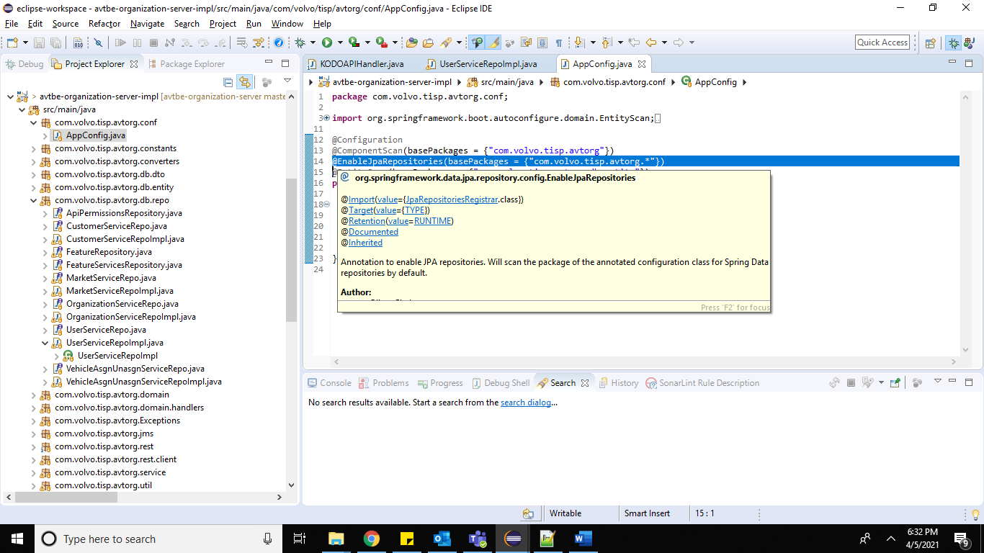

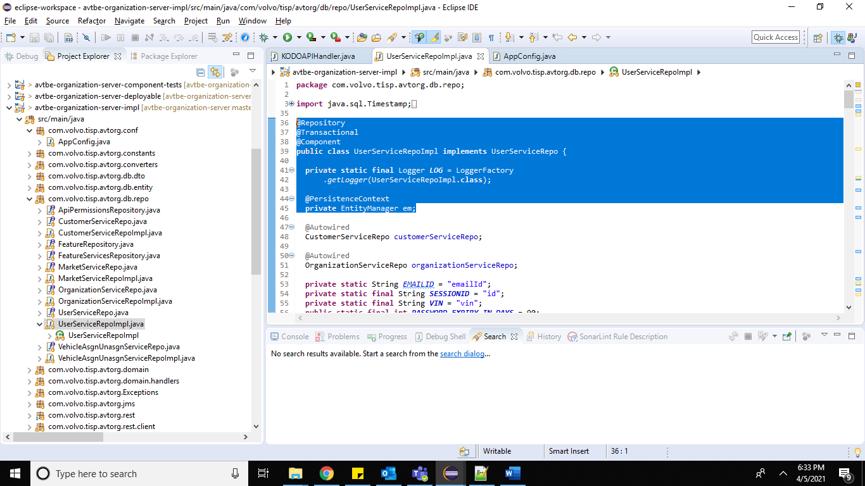

Query query = em.createNamedQuery("getUserByEmail");

user = em.find(UserMaster.**class**, userId);

Query qry = em.createNativeQuery(“pass SQL Query”);

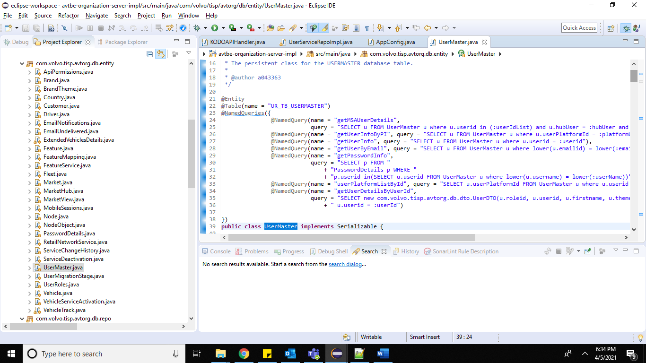

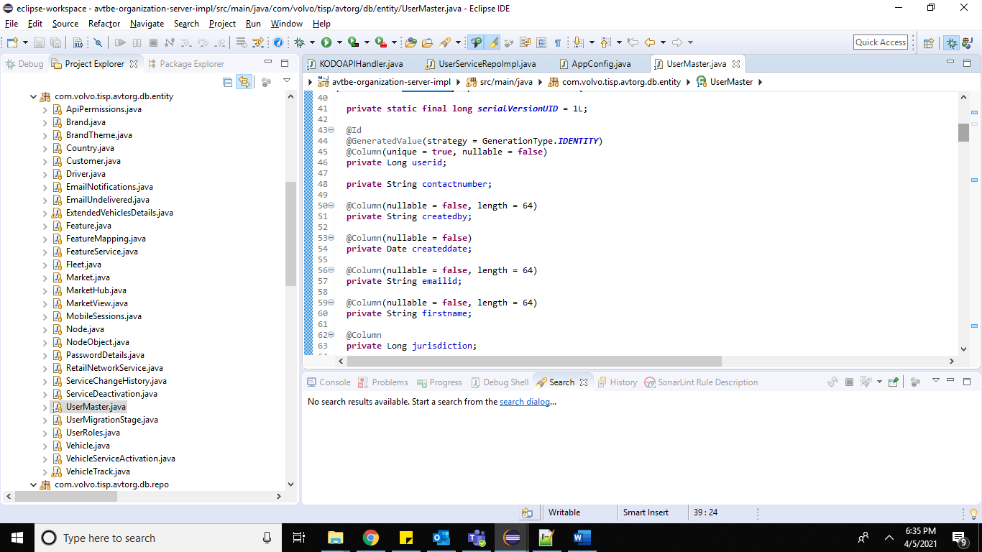

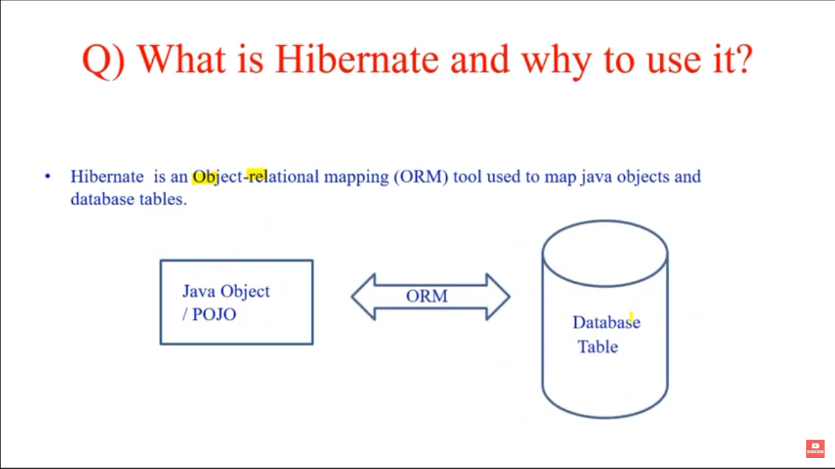

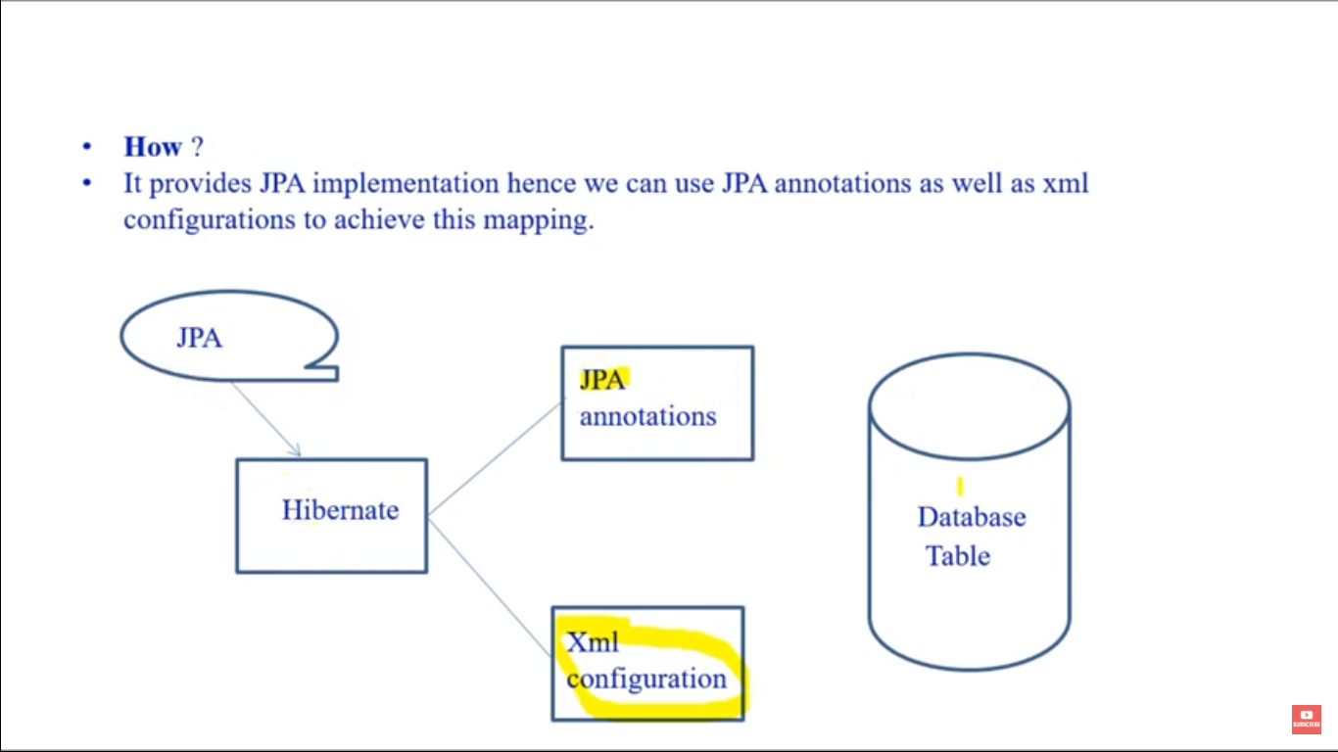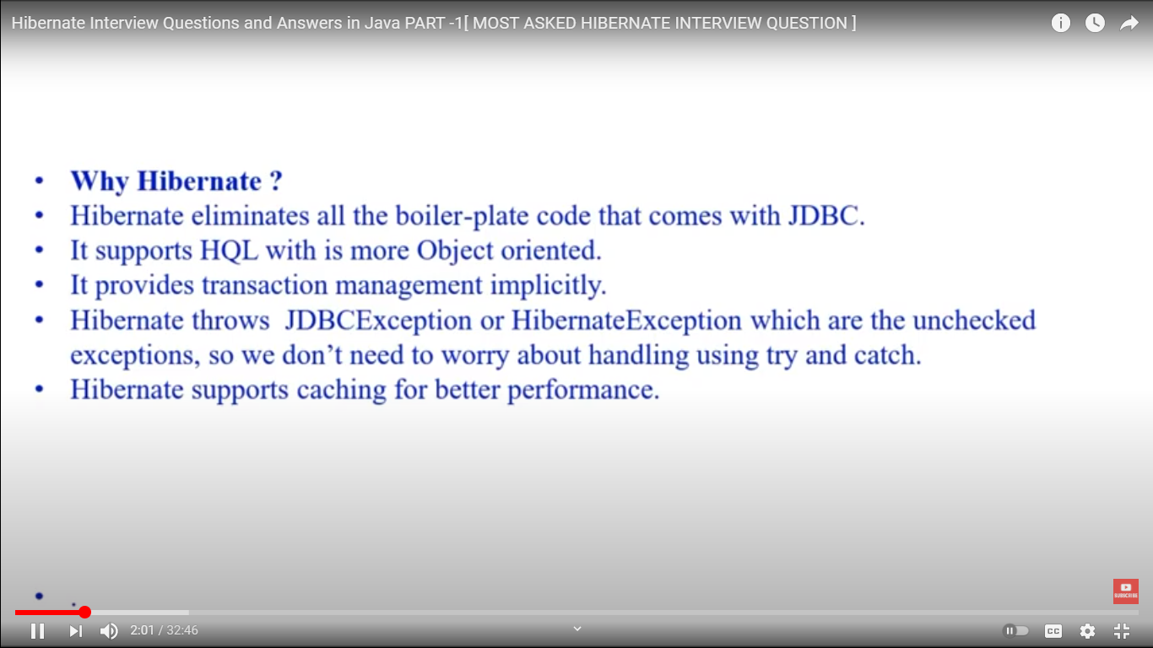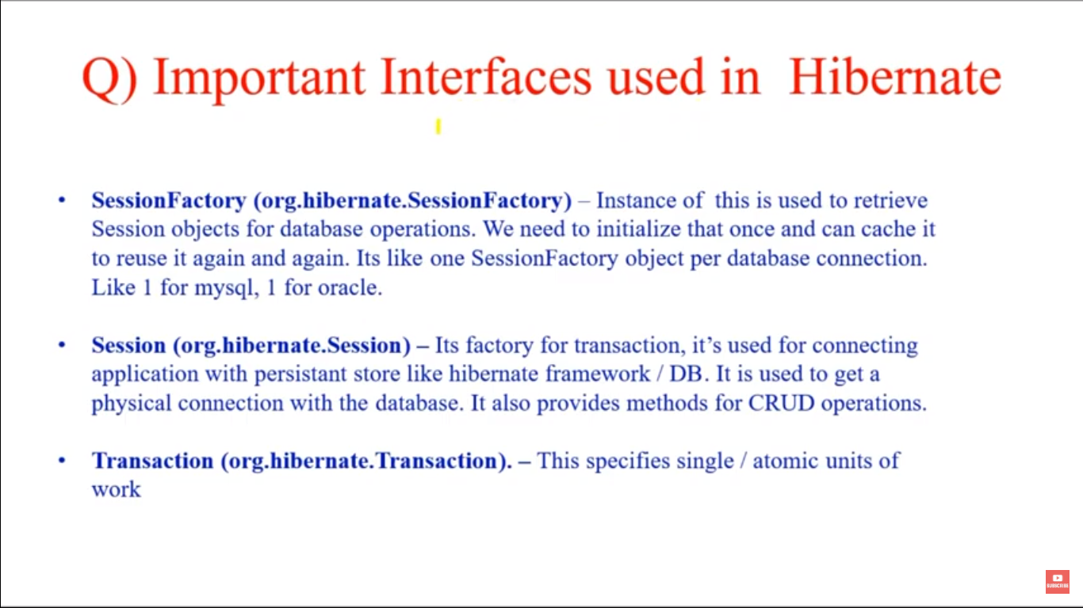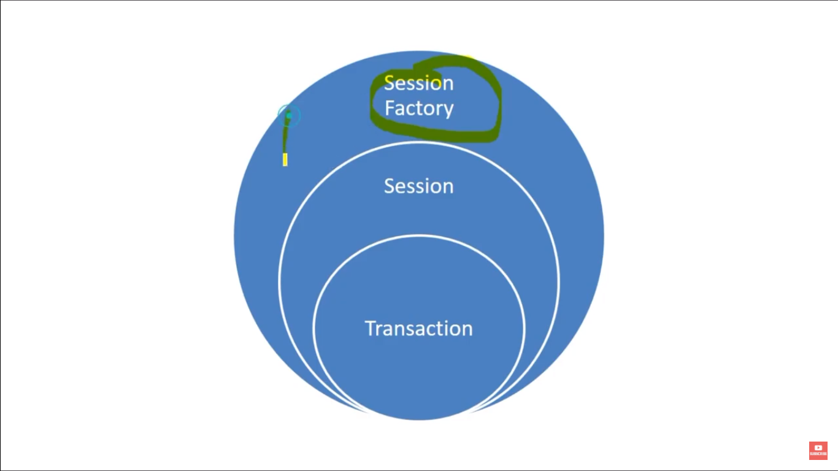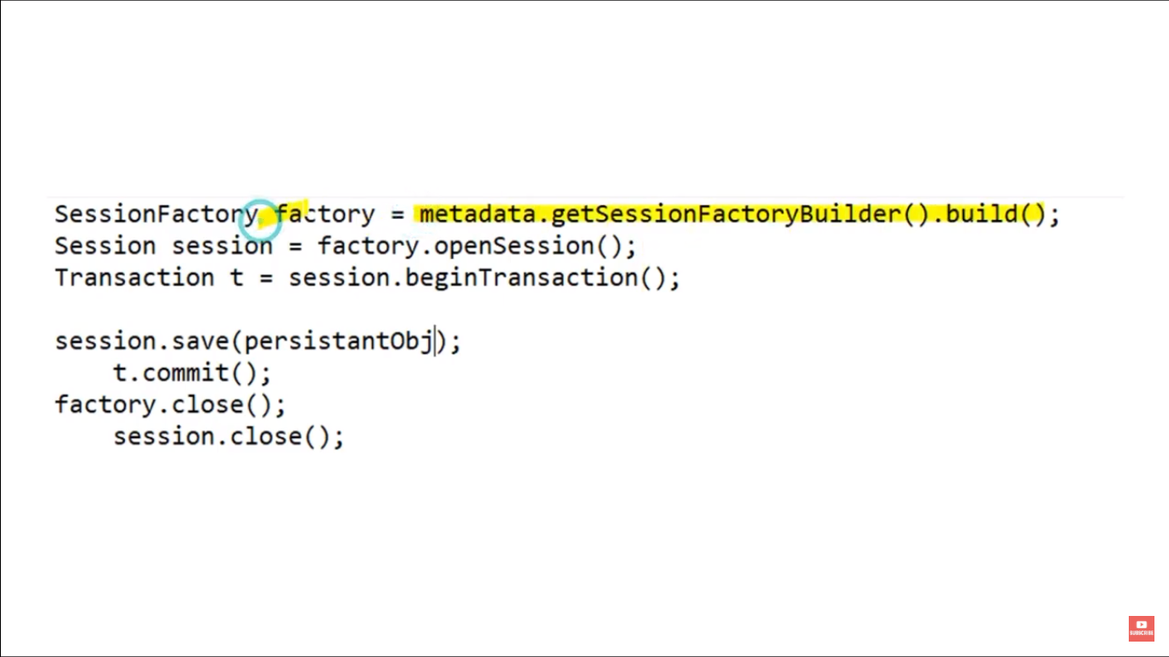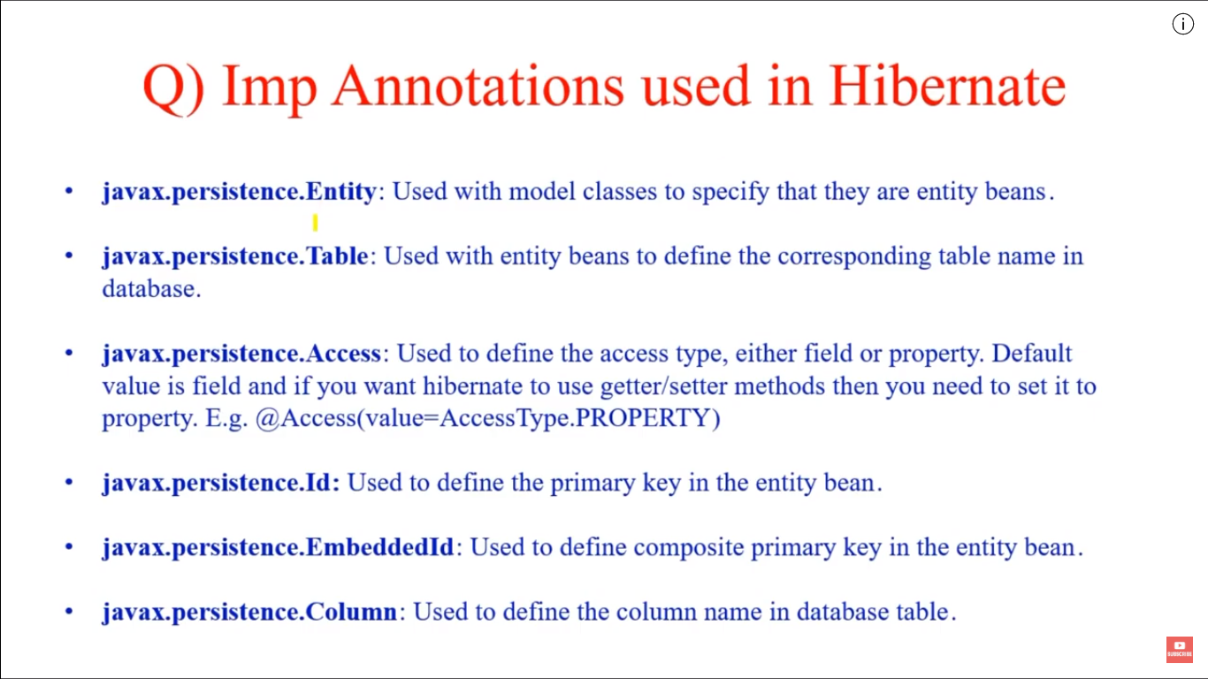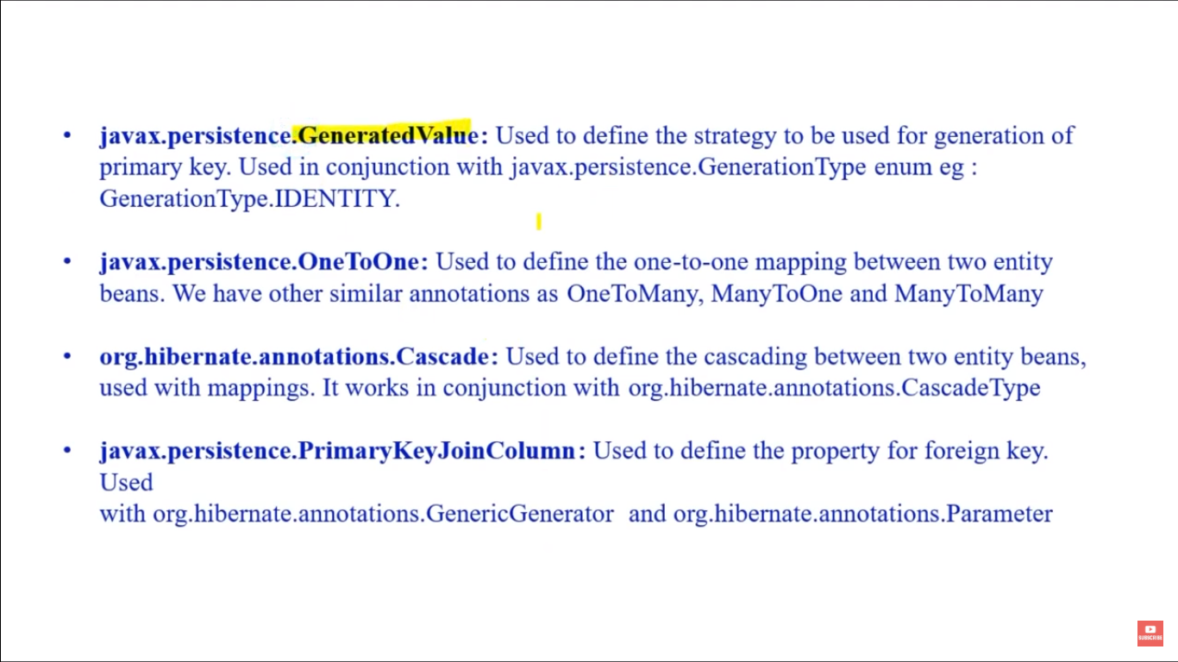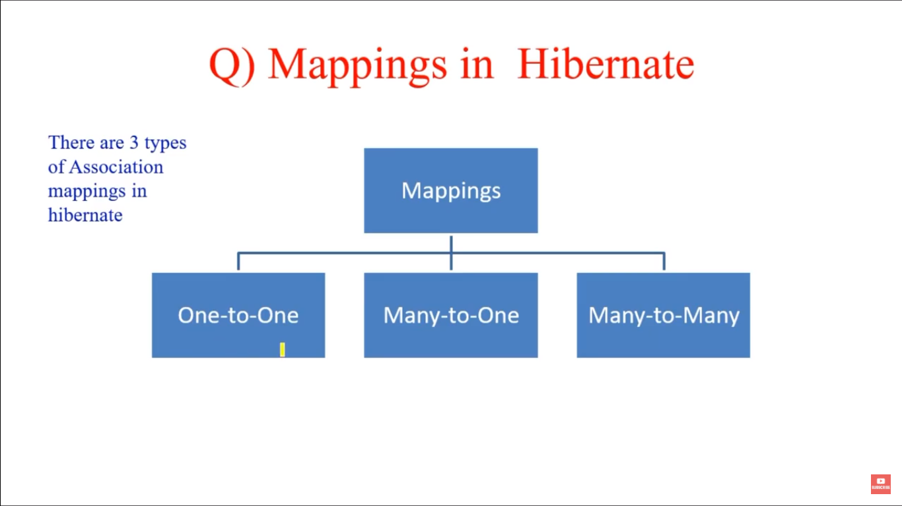

Employee.java we can add below code for 1-to-1 to CodeDecode.java

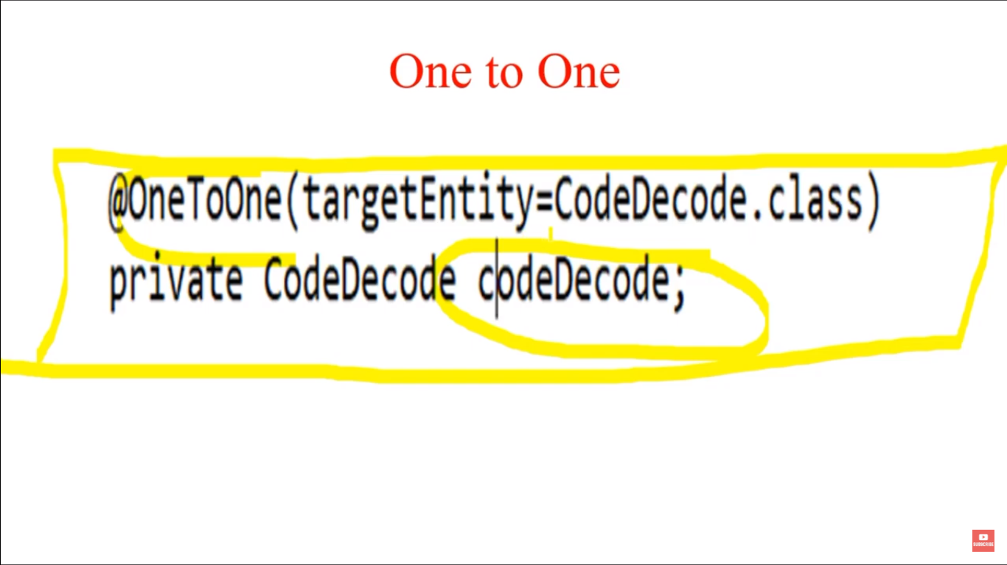

**One to Many and Many-to-one**

The mapping related configurations will be done using JPA annotations in the model classes:

@Entity

@Table(name="CART")

**public** **class** **Cart** {

//...

@OneToMany(mappedBy="cart")

**private** Set<Items> items;

// getters and setters

}

Please note that the @OneToMany annotation is used to define the property in Items class that will be used to map the mappedBy variable. That is why we have a property named “cart” in the Items class:

@Entity

@Table(name="ITEMS")

**public** **class** **Items** {

//...

@ManyToOne

@JoinColumn(name="cart_id", nullable=false)

**private** Cart cart;

**public** **Items**() {}

// getters and setters

}

It's also important to note that the @ManyToOne annotation is associated with the Cart class variable. @JoinColumn annotation references the mapped column.

Many-to-Many:

# 

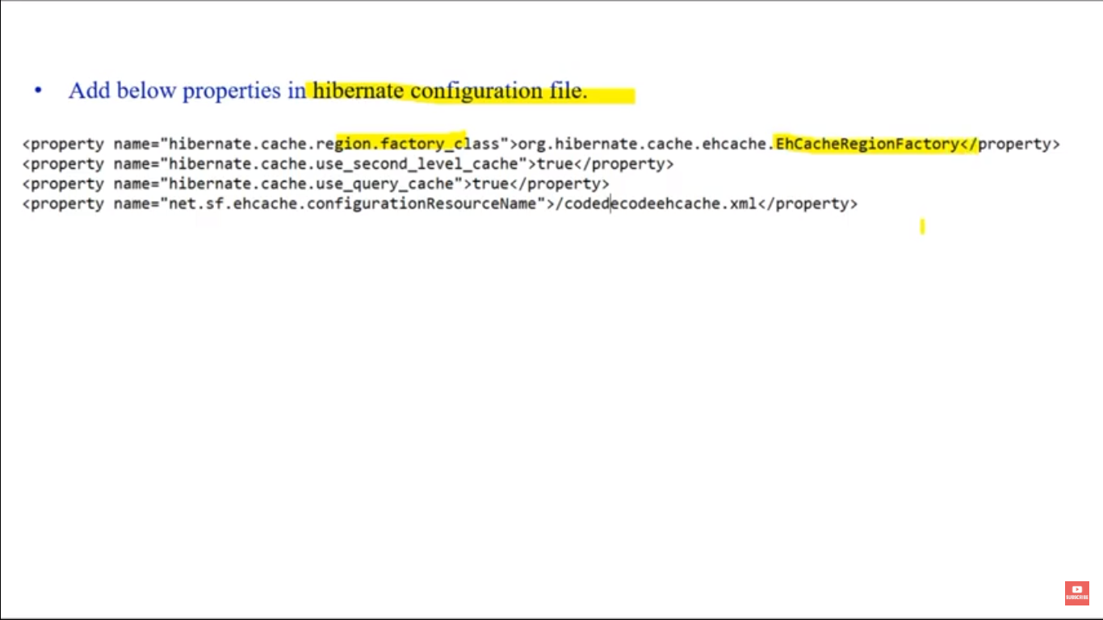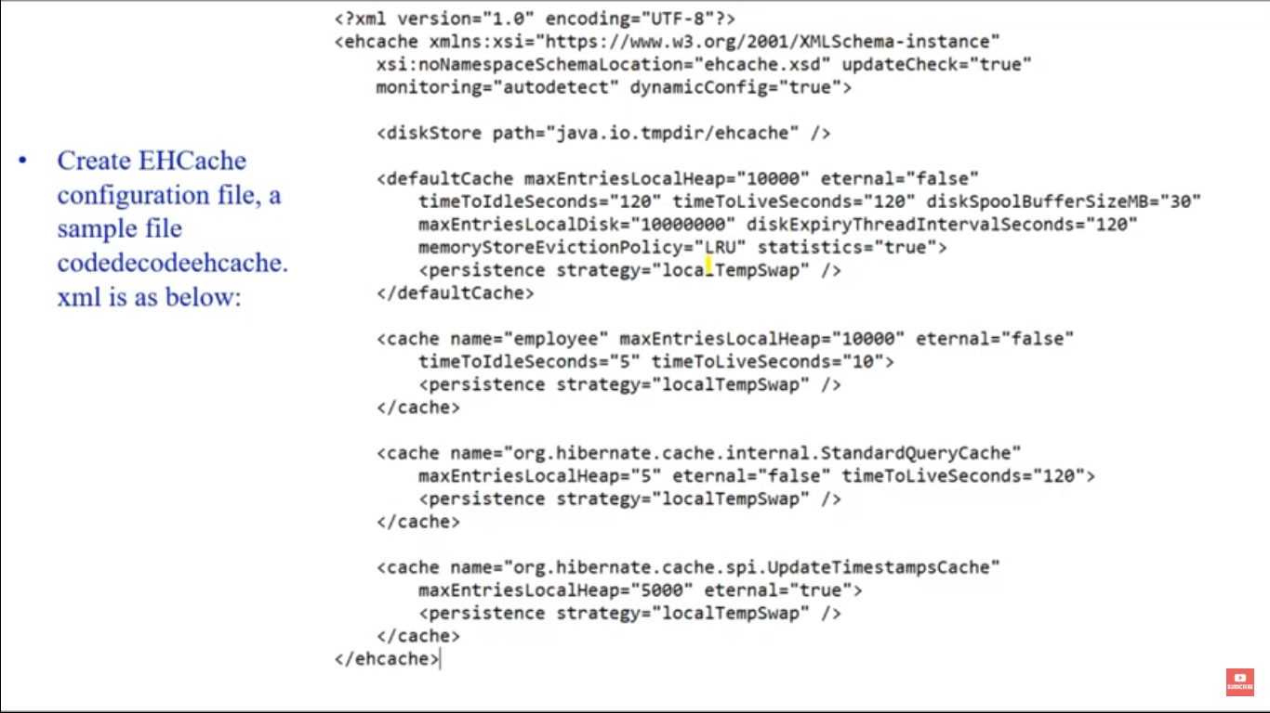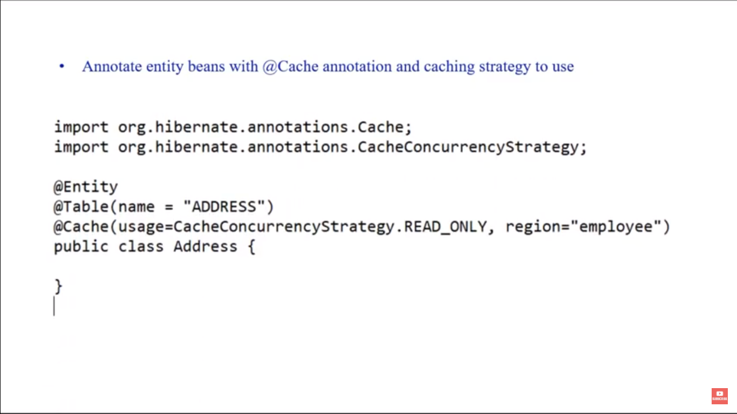

**diskStore:** EHCache stores data into memory but when it starts overflowing, it start writing data into file system. We use this property to define the location where EHCache will write the overflown data.

**defaultCache:** It’s a mandatory configuration, it is used when an Object need to be cached and there are no caching regions defined for that.

**cache name=”employee”:** We use cache element to define the region and it’s configurations. We can define multiple regions and their properties, while defining model beans cache properties, we can also define region with caching strategies. The cache properties are easy to understand and clear with the name.

Cache regions **org.hibernate.cache.internal.StandardQueryCache** and **org.hibernate.cache.spi.UpdateTimestampsCache** are defined because EHCache was giving warning to that.

**Cache refresh is handled by below 2 parameters :**

timeToLiveSeconds=""

timeToIdleSeconds=""

**timeToLiveSeconds(TTL) :** Is the time in seconds from the point of creation in the cache till it expires. i.e. the maximum time between creation time and when an element expires.

The maximum number of seconds an element can exist in the cache regardless of use (regardless of how frequently it is accessed in that time).

The element expires at this limit and will no longer be returned from the cache. If the value is 0, it means no TTL eviction takes place (infinite lifetime).

**timeToIdleSeconds(TTI) :**Is the time in seconds before an object in the cache expires if it is not accessed, i.e. it sets the time to idle for an element before it expires.

The maximum number of seconds an element can exist in the cache without being accessed.

The element expires at this limit and will no longer be returned from the cache. If the value is 0, it means no TTI eviction takes place (infinite lifetime).

**Data freshness / Expiry:** Data in cache can expire in order to guarantee that what the cache returns does not become stale. This is controlled in Ehcache 2.x by different attributes:

**eternal attribute -** if true indicates that mappings never expire,

**time to live (TTL) -** a duration after the cache mapping was created,

**and/or time to idle (TTI)** - a duration after the cache mapping was last accessed

**Capacity control / Eviction:** Limit the cache size so that you do not exhaust memory of your application by filling up a cache

When the maximum number of mappings is reached, the cache will start evicting entries - the exact entry evicted depends from the cache configuration / implementation

SpringBoot+Hibernate +JPA +SQL::

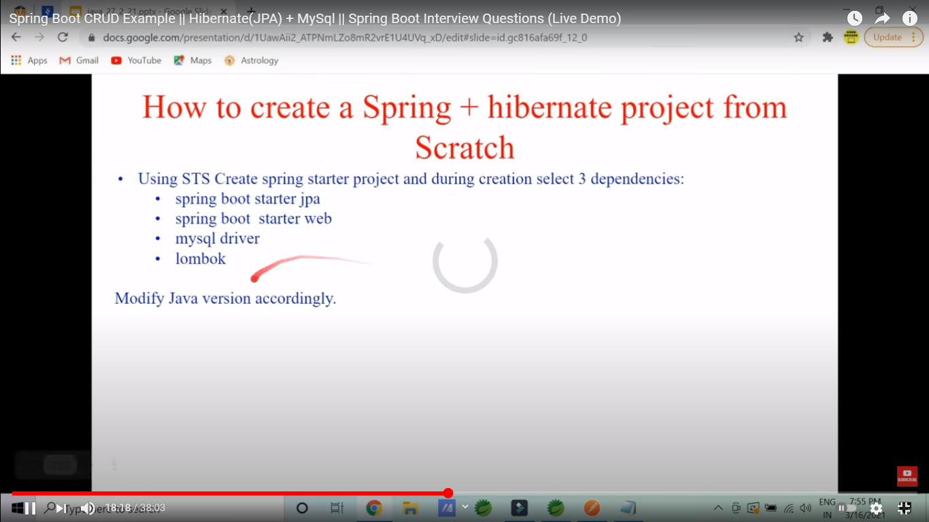

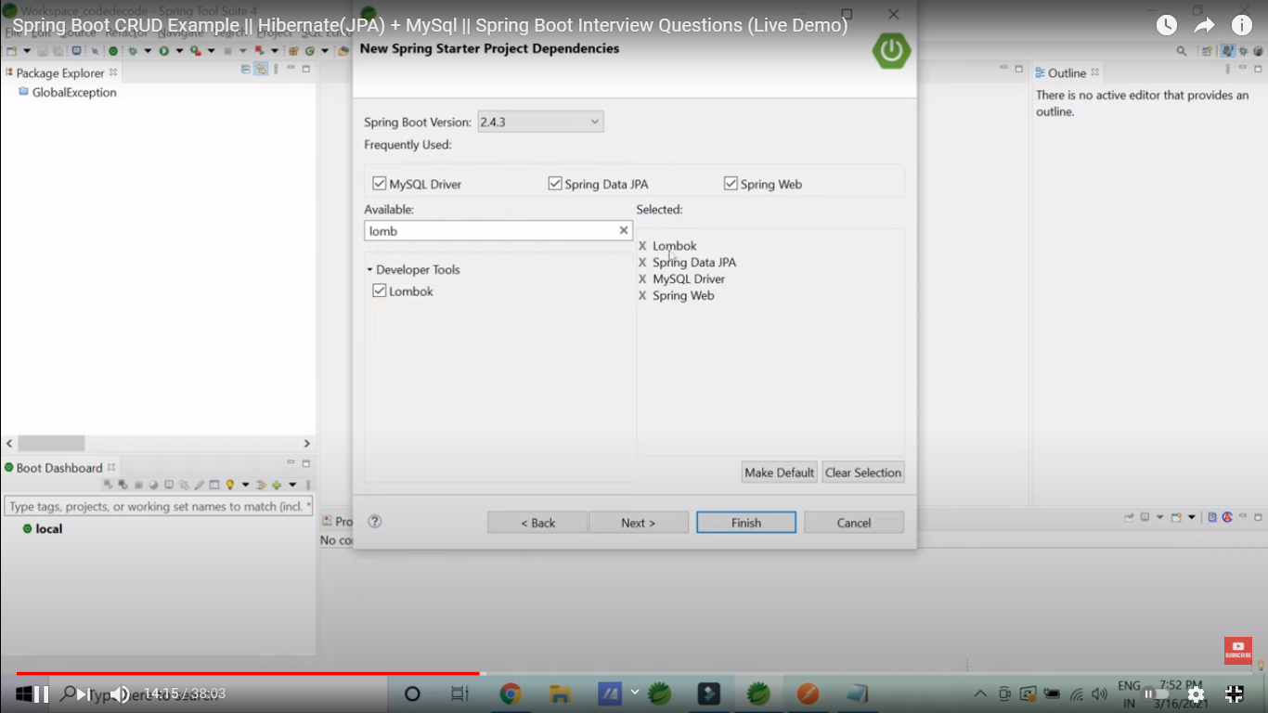

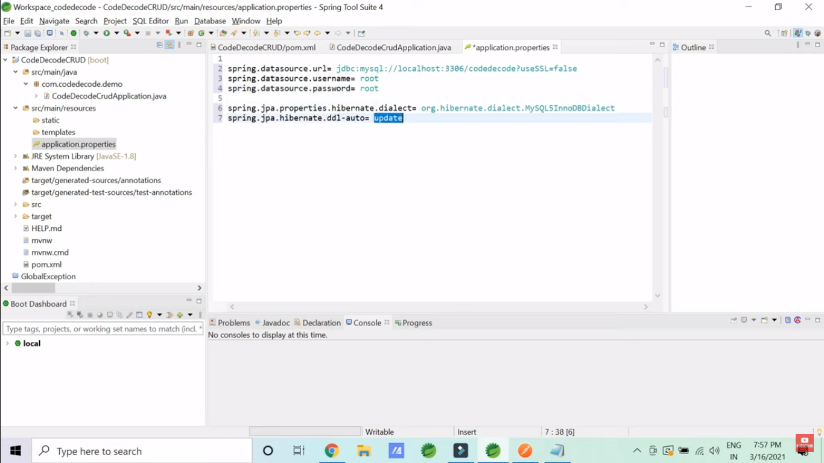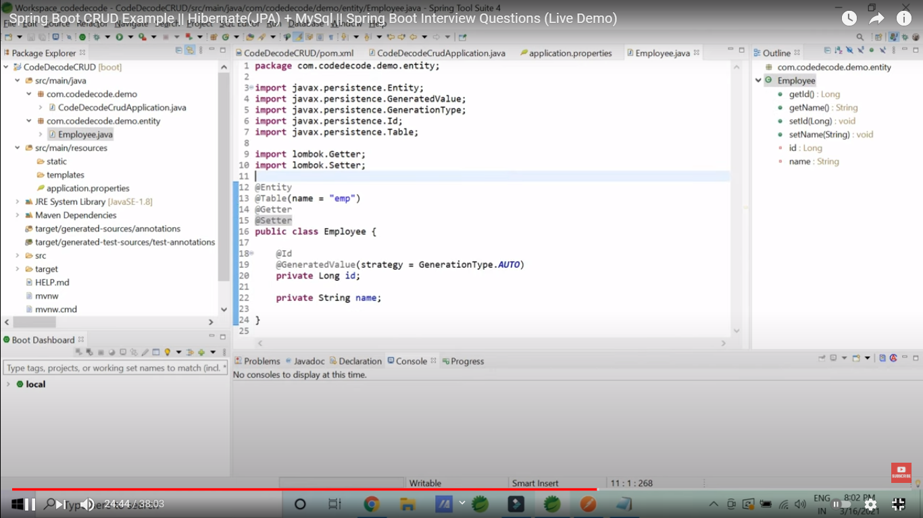

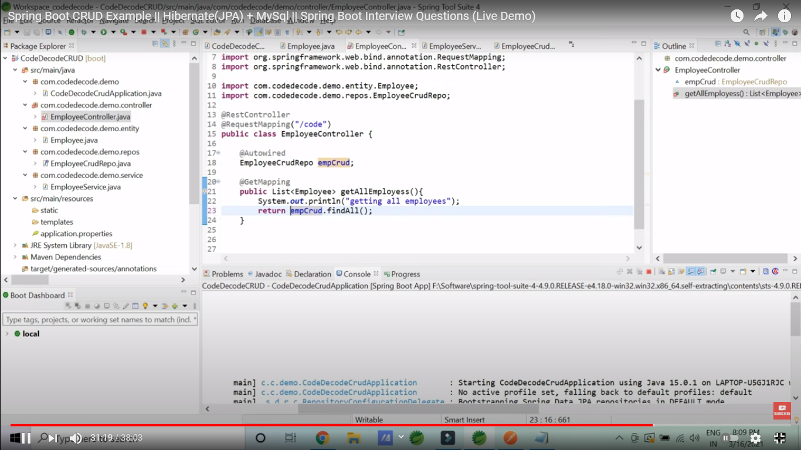

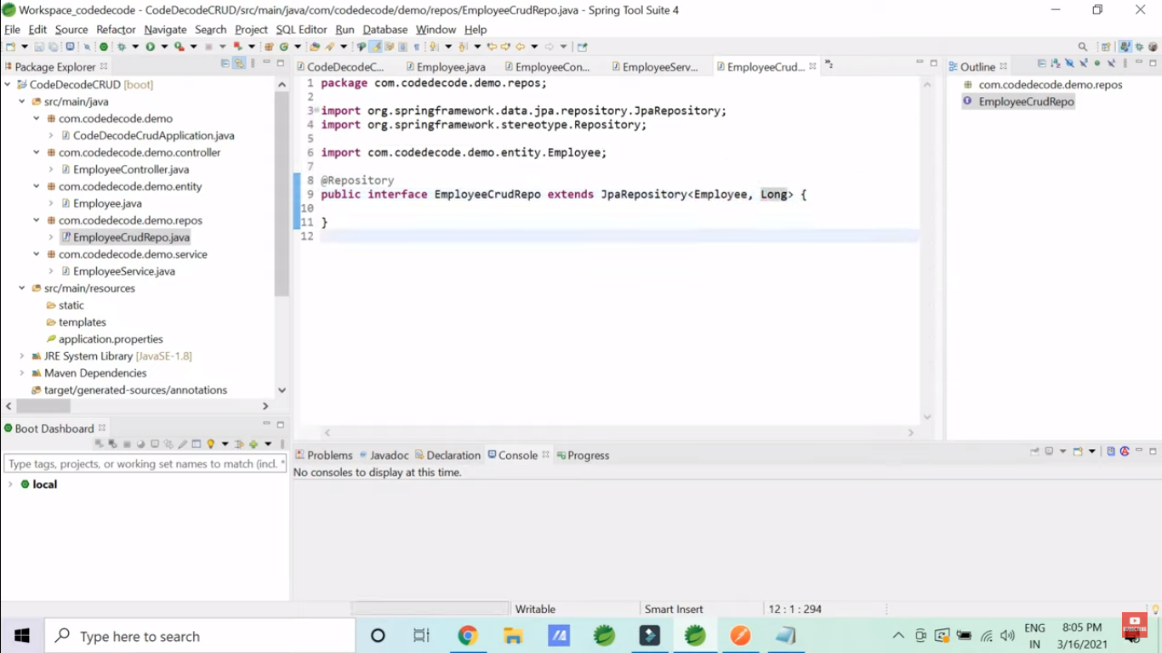

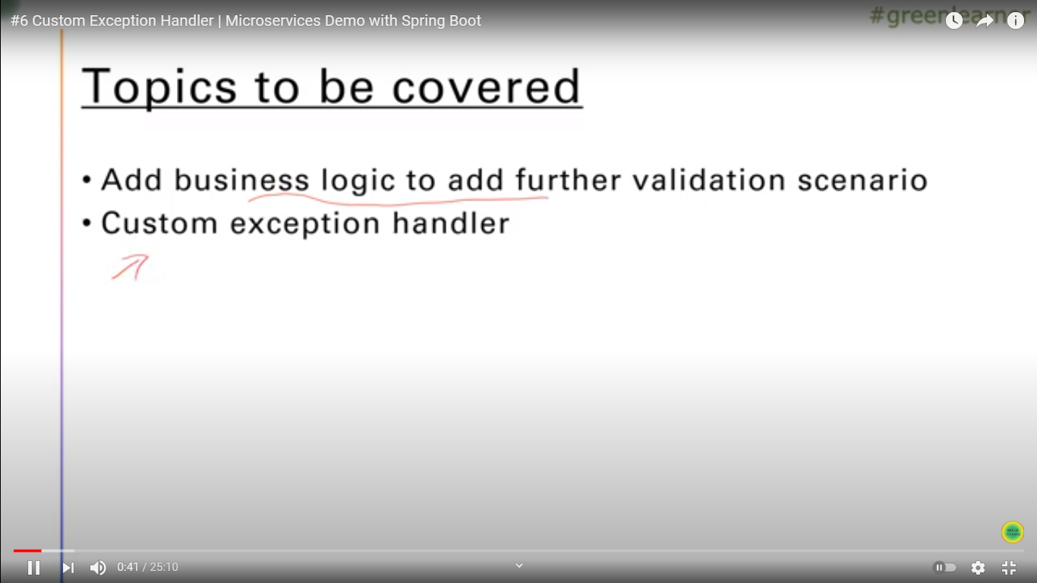

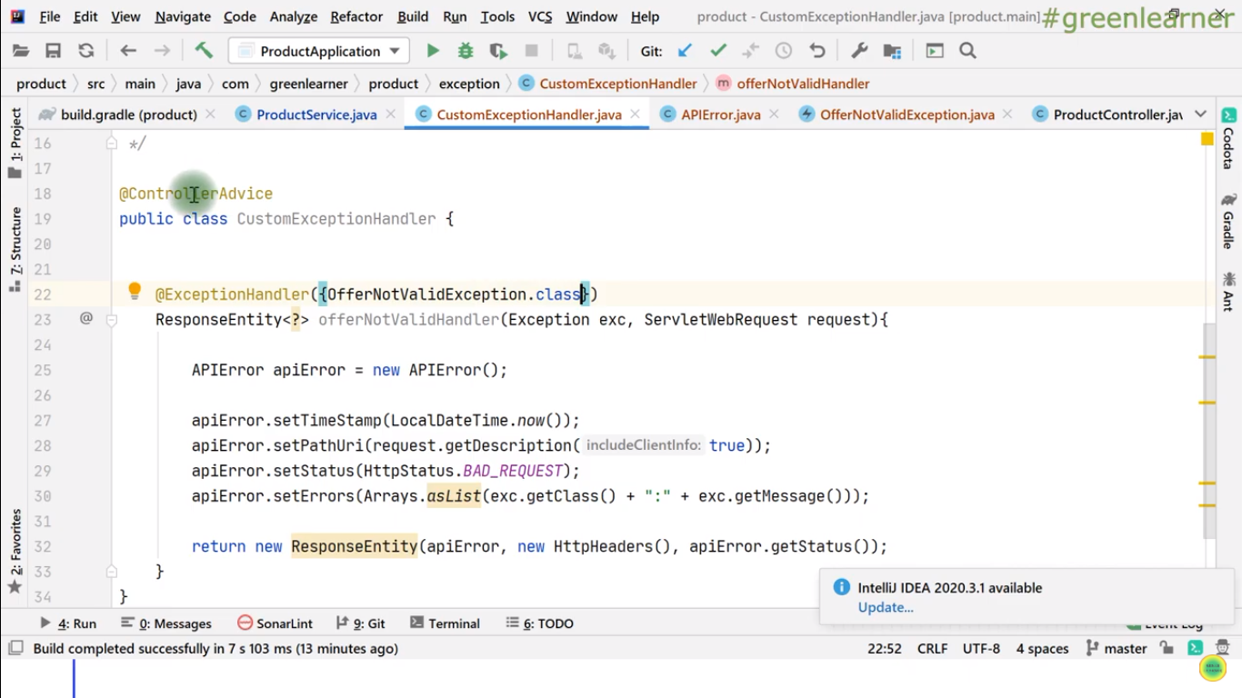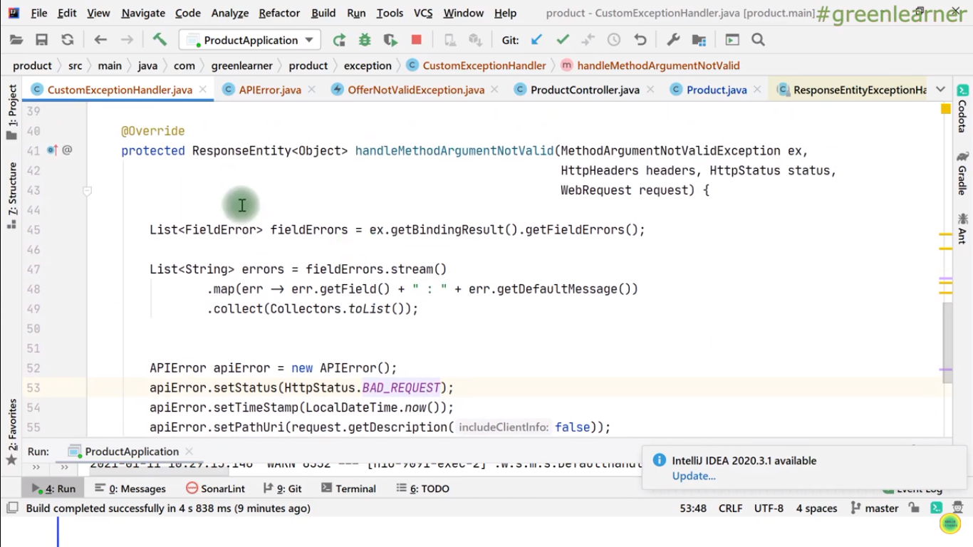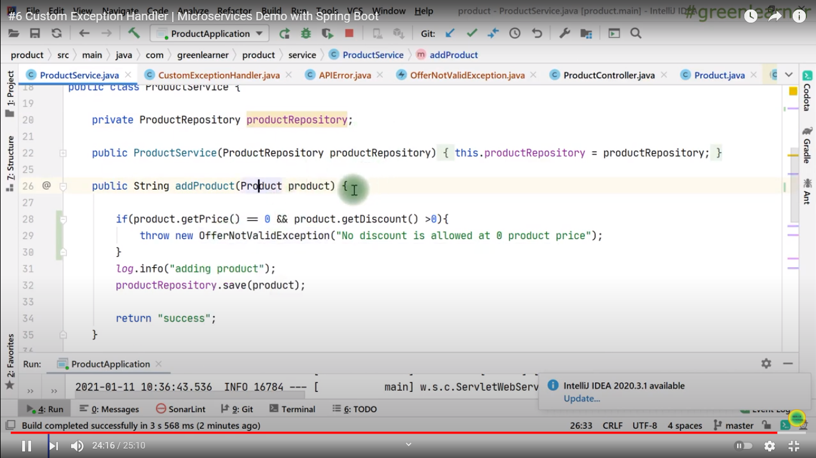

**Inheritance in Hibernate:**

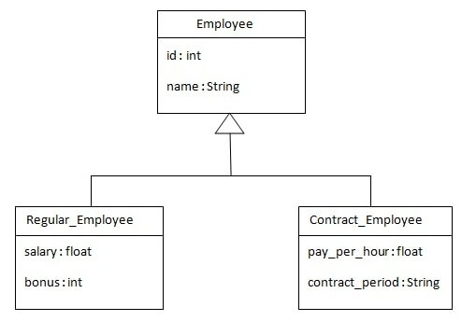

**3 types of Inheritences we have in Hibernate.**

1. Table Per Hierarchy
2. Table Per Concrete class
3. Table Per Subclass

***1.Employee:***

*@Entity*

*@Table(name = "employee101")*

*@Inheritance(strategy=InheritanceType.SINGLE_TABLE)*

*@DiscriminatorColumn(name="type",discriminatorType=DiscriminatorType.STRING)*

*@DiscriminatorValue(value="employee")*

***public******class****Employee {*

*@Id*

*@GeneratedValue(strategy=GenerationType.AUTO)*

*@Column(name = "id")*

***private******int****id;*

@Column(name = "name")

**private** String name;

//setters and getters

}

***2.Regular_Employee***

*@Entity*

*@DiscriminatorValue("regularemployee")*

***public******class****Regular_Employee****extends****Employee{*

*@Column(name="salary")*

***private******float****salary;*

*@Column(name="bonus")*

***private******int****bonus;*

*//setters and getters*

*}*

***3.Contrace_Employee:***

*@Entity*

*@DiscriminatorValue("contractemployee")*

***public******class****Contract_Employee****extends****Employee{*

*@Column(name="pay_per_hour")*

***private******float****pay_per_hour;*

*@Column(name="contract_duration")*

***private****String contract_duration;*

*//setters and getters*

*}*

***1.Table per hierarchy***

@Inheritance(strategy=InheritanceType.SINGLE_TABLE)

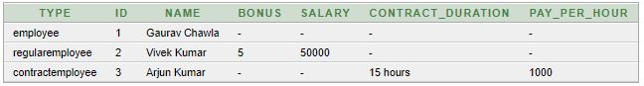

***2.Table per Class***

In case of Table Per Concrete class, tables are created per class. So there are no nullable values in the table. Disadvantage of this approach is that duplicate columns are created in the subclass tables.

@Inheritance(strategy=InheritanceType.TABEE_PER_CLASS)

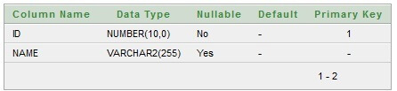

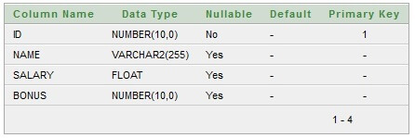

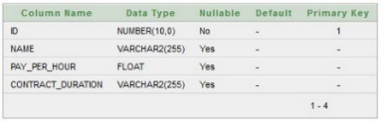

***3.Table per Sub Class***

As we have specified earlier, in case of table per subclass strategy, tables are created as per persistent classes but they are treated using primary and foreign key. So there will not be any duplicate column in the relation.

We need to specify @Inheritance(strategy=InheritanceType.JOINED) in the parent class and @PrimaryKeyJoinColumn annotation in the subclasses.@Inheritance(strategy=InheritanceType. JOINED)



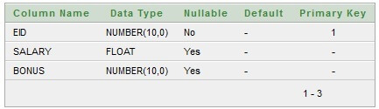

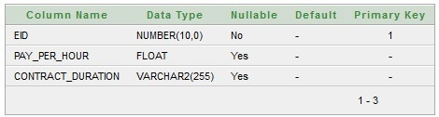

1. We need to add @PrimaryKeyJoinColumn(name="ID")  on sub classes.